Bangladesh Medical Association (BMA)
List of Life Member-42
61. BMA Sherpur Branch

Sl No | Voter No | Voter Details
1 | Voter No  LM-6100001  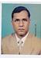 | DR. MD. SURUZZAMAN  F/Name: Md. Abdul Kuddus.  M/Name:  BM & DC Reg. No:  NID:  Cell:  Address: 118, Kalir Bazar  Sherpur Town  Sherpur  Blood Group:
2 | Voter No  LM-6100002  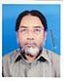 | DR. MD. ABDUL JALIL  F/Name:  M/Name:  BM & DC Reg. No:  NID:  Cell:  Address: Bograksha  Sherpur Town  Sherpur  Blood Group:
3 | Voter No  LM-6100003  No Image | DR. MD. AMINUL HAQUE AKHANDA  F/Name:  M/Name:  BM & DC Reg. No:  NID:  Cell:  Address:  Blood Group:  TRANSFERED to BMA Dhaka City  LM-1405543
4 | Voter No  LM-6100004  No Image | DR. MD. JAHANGIR KHALED  F/Name:  M/Name:  BM & DC Reg. No:  NID:  Cell:  Address: Meghmaya Kharampur  Sherpur Town  Sherpur  Blood Group:
5 | Voter No  LM-6100005  No Image | DR. AMARESH CHANDRA SHAHA  F/Name:  M/Name:  BM & DC Reg. No:  NID:  Cell:  Address:  Blood Group:  TRANSFERED to BMA Dhaka City  LM-1405543
6 | Voter No  LM-6100006  No Image | DR. SUSHIL CHANDRA SUTRADHAR  F/Name:  M/Name:  BM & DC Reg. No:  NID:  Cell:  Address: Dist Family Planing Office  Sherpur.  Blood Group:
7 | Voter No  LM-6100007  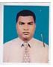 | DR. A.T.M. MAMUN  F/Name:  M/Name:  BM & DC Reg. No:  NID:  Cell:  Address: Mohsinia Pharmacy  Sherpur Town  Sherpur  Blood Group:
8 | Voter No  LM-6100008  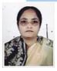 | DR. NARGIS BEGUM  F/Name:  M/Name:  BM & DC Reg. No:  NID:  Cell:  Address: Staff Quarter  Sadar Hospital  Sherpur  Blood Group:
9 | Voter No  LM-6100009  No Image | DR. MD. YUSUF ALI  F/Name:  M/Name:  BM & DC Reg. No:  NID:  Cell:  Address:  Blood Group:  TRANSFERED to BMA Dhaka City  LM-1405543
10 | Voter No  LM-6100010  No Image | DR. E.R. CHAUDHURY  F/Name:  M/Name:  BM & DC Reg. No:  NID:  Cell:  Address: Civil Surgeon  Sherpur  Blood Group:
11 | Voter No  LM-6100011  No Image | DR. SYED ANISUR RAHMAN  F/Name:  M/Name:  BM & DC Reg. No: 6943  NID:  Cell:  Address: N/A  Blood Group:  TRANSFERED to BMA Dhaka City  LM-1405543
12 | Voter No  LM-6100012  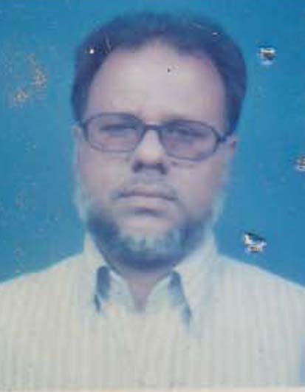 | DR. MD. AMINUR RAHMAN  F/Name: Late. Munir Uddin  M/Name: Mrs. Joynob Nessa  BM & DC Reg. No: 20965  NID:  Cell: 01552441957  Address: Fair Medicare Centre, Taraganj Dakkhin Bazar, Naritabar Dist:Sherpur  Blood Group: O+
13 | Voter No  LM-6100013  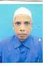 | DR. MD. ABDUL MOBARAK  F/Name: Late Md. Abul Quasem  M/Name:  BM & DC Reg. No:  NID:  Cell:  Address: Vill+Post: Hatibanha.  Upazila Jhcnaigati ,Dist:Sherpur  Blood Group:
14 | Voter No  LM-6100014  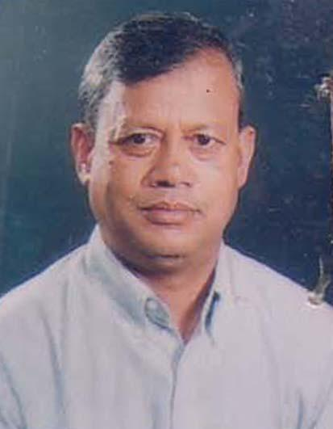 | DR. MOHAMMED ABDUL BAREQUE  F/Name: Late. Afaz Uddin  M/Name: Mrs. Fulman Begum  BM & DC Reg. No: 18663  NID: 8928804123015  Cell: 01712858315  Address: Chawkpathak, Sherpur Town, Dist: Sherpur  Blood Group: B+
15 | Voter No  LM-6100015  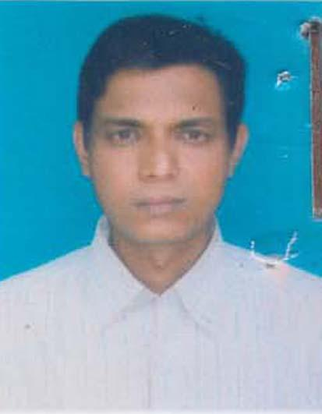 | DR. MD. SIDDIQUE ULLAH  F/Name: Md. Ismail Hossain  M/Name: Late. Hamida Khatun  BM & DC Reg. No: 28600  NID:  Cell:  Address: Fair Medicare Centre, Taraganj Dakkhin Bazar, Naritabar Dist:Sherpur  Blood Group: B+
16 | Voter No  LM-6100016  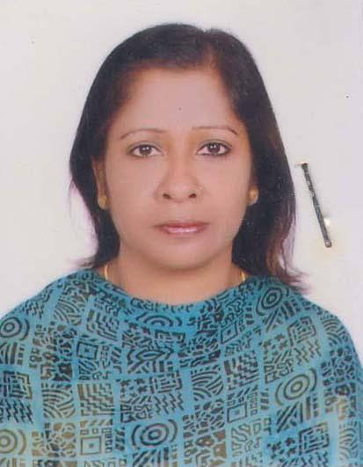 | DR. SAHERA KHATUN  F/Name: Md. Eusuf Ali  M/Name: Mrs. Aktara Begum  BM & DC Reg. No: 34305  NID: 8928802112817  Cell: 01716106968  Address: Mohsinia Pharmacy, Rofhunath Bazar, Sherpur Town, Sherpur- 2100  Blood Group: B+
17 | Voter No  LM-6100017  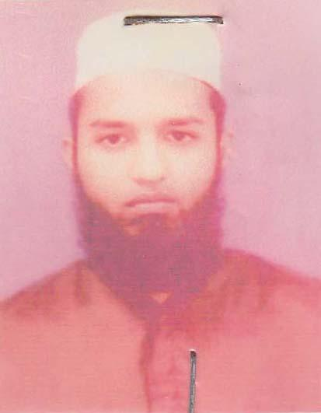 | DR. MD. SHARIF HASAN  F/Name: Md. Shahjahan  M/Name: Sayeda Sufia Begum  BM & DC Reg. No: 49313  NID:  Cell: 01717496197  Address: Doctors Quarter(1st floor) Upazila Health Complex, Nalitabari, Sherpur  Blood Group: O+
18 | Voter No  LM-6100018 | DR. MD. ASRAQUR RAHMAN RAIHAN  F/Name: Md. Abdul Latif Miah  M/Name: Asma Khatun  BM & DC Reg. No: 2685  NID:  Cell: 01712650420  Address: House No 40 Road No- 7/2 Gouripur Kazibari Pukur Sherpur Town Sherpur  Blood Group:
19 | Voter No  LM-6100019  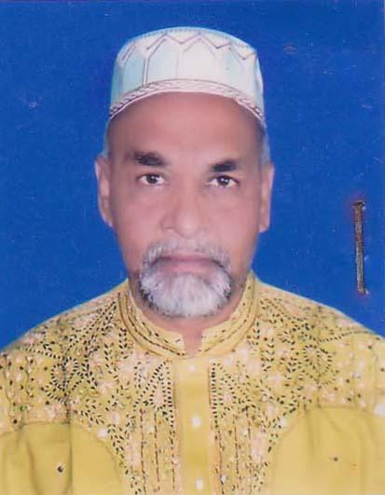 | DR. MD. MUZAHIDUL ISLAM  F/Name: Late. Bahar Uddin  M/Name: Late. Meraja Khatun  BM & DC Reg. No: 22923  NID: 8929009075752  Cell: 01718307763  Address: Vill: Satani Sribordi, PS: Sribordi, Dist: Sherpur  Blood Group: B+
20 | Voter No  LM-6100020  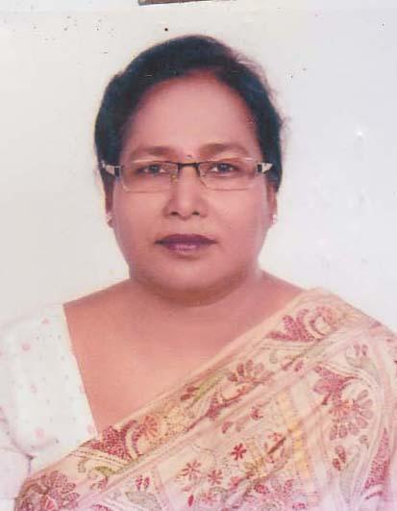 | DR. BUSHRA AMENA  F/Name: Late Md. Squasem  M/Name: Meherunnahar  BM & DC Reg. No: 18384  NID: 892880413014  Cell: 01715007314  Address: Chakparayher, Sherpur Town, Sherpur 2100  Blood Group: B+
21 | Voter No  LM-6100021  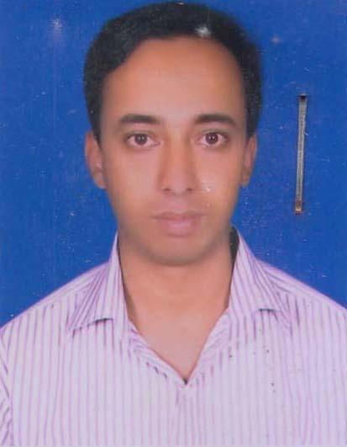 | DR. MD. MUBARAK HOSSAIN  F/Name: Md. Abdul Latif  M/Name: Mrs. Moriom Begum  BM & DC Reg. No: 50660  NID: 4798516214832  Cell: 01978151161  Address: Vill: Howra Goar, PO: Shapmari, PS: Sherpur Sadar, Dist: Sherpur  Blood Group: B+
22 | Voter No  LM-6100022  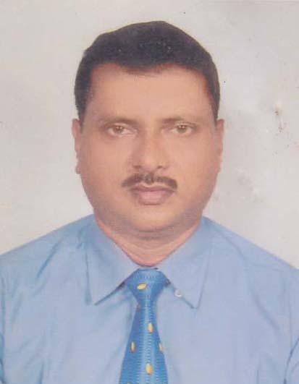 | DR. PIJUSH CHANDRA SUTRADHAR  F/Name: Late. Hirendra Chandra Sutradhar  M/Name: Promoda Sutradhar  BM & DC Reg. No: 24289  NID: 8928802109501  Cell: 01712103606  Address: Maternal & Child Welfare Center (MCWC), Sherpur-2100  Blood Group: O+
23 | Voter No  LM-6100023 | DR. MOHAMMAD KHAIRUL KABIR  F/Name: Mohammad Mahiuddin  M/Name: Nurun Nahar  BM & DC Reg. No: 46752  NID: 8928807146976  Cell: 01711044586  Address: Jeebaigati Health Complex, Jhenaigati, Sherpur  Blood Group: A-
24 | Voter No  LM-6100024  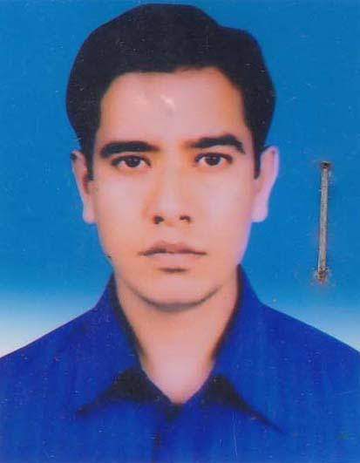 | DR. MD. SHAHIDUL ISLAM  F/Name: Md. Abdul Gofur Sarker  M/Name: Most. Fatema Khatun  BM & DC Reg. No: 33485  NID: 8524904189484  Cell: 01717525241  Address: Sadar Hospital, Sherpur  Blood Group: B+
25 | Voter No  LM-6100025  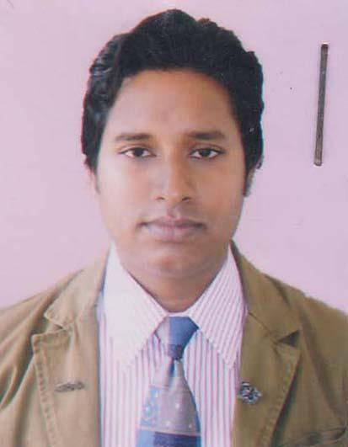 | DR. TITUL KUMAR SAHA  F/Name: Kali Sankar Saha  M/Name: Momita Rani Saha  BM & DC Reg. No: 47734  NID: 8928803114446  Cell: 01717783880  Address: House no:93, Road No: 6, Section: A, Shib Bari, Sherpur Town, Sherpur-2100  Blood Group: B+
26 | Voter No  LM-6100026  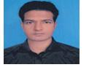 | DR. MOHAMMAD GAUSUZZAMAN  F/Name: Md. Aminul Haque  M/Name: Mahmoda Khatiun  BM & DC Reg. No: 2758  NID:  Cell: 01721441777  Address: 249/1 Uttar Guuripur Sherpur Town Sherpur  Blood Group:
27 | Voter No  LM-6100027 | DR. MINTO CHANDRA PAUL  F/Name: Khushi Mohon Paul  M/Name: Anjali Rani Paul  BM & DC Reg. No: 37576  NID: 8918820272176  Cell: 01712293008  Address: Vill- Boyra Paranpur, P.O-Maddha Boyara Bazar, P.S + Dist- Sherpur  Blood Group: B+
28 | Voter No  LM-6100028  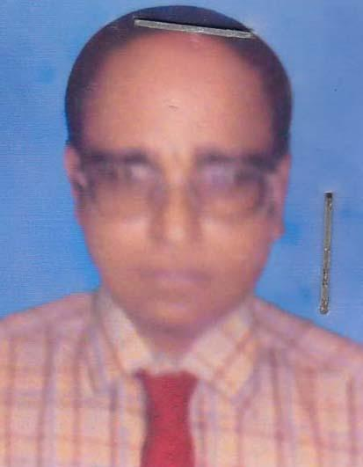 | DR. MD. MUSTAFIZUR RAHMAN  F/Name: Late. Md. Fazar Uddin Sarkar  M/Name: Fulmati Begum  BM & DC Reg. No: 21898  NID: 3910723426309  Cell: 01711406756  Address: Mo Clinic Mcwc Sherpur.  Blood Group: O+
29 | Voter No  LM-6100029  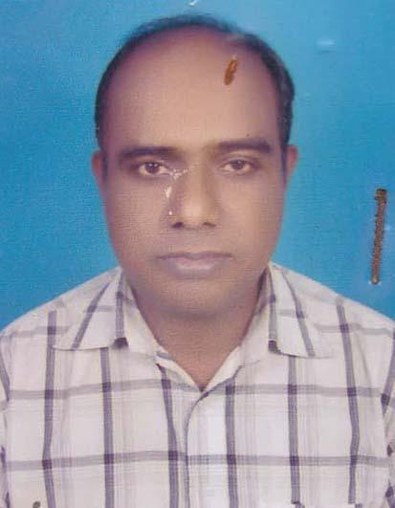 | DR. MD. SELIM MIAH  F/Name: Late. Mohammad Ali  M/Name: Hamida Begum  BM & DC Reg. No: 25547  NID: 8928806137131  Cell: 01552390314  Address: Gouripur, Sherpur Town, Sherpur 2100  Blood Group: B+
30 | Voter No  LM-6100030  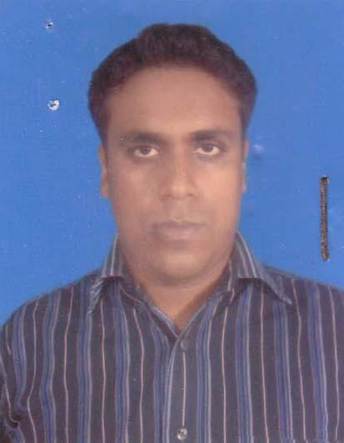 | DR. NILADREE HARE  F/Name: Nitai Lal Hore  M/Name: Dipali Hore  BM & DC Reg. No: 43982  NID: 8928802108279  Cell: 01725402479  Address: Botla, Sherpur Town, Sherpur  Blood Group: B+
31 | Voter No  LM-6100031  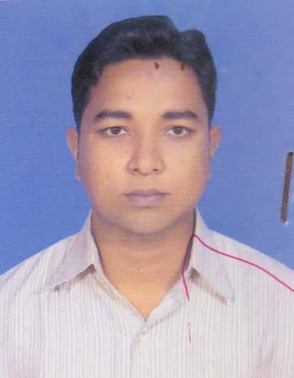 | DR. AVIJIT HORE  F/Name: Ranajit Kumar Hore  M/Name: Milon Rani Hore  BM & DC Reg. No: 89180  NID: 8918820272120  Cell: 01717179992  Address: Vill- Boyra Poranpur, P.O-Sherpur Town, P.S-Sherpur, Dist- Sherpur  Blood Group: B+
32 | Voter No  LM-6100032  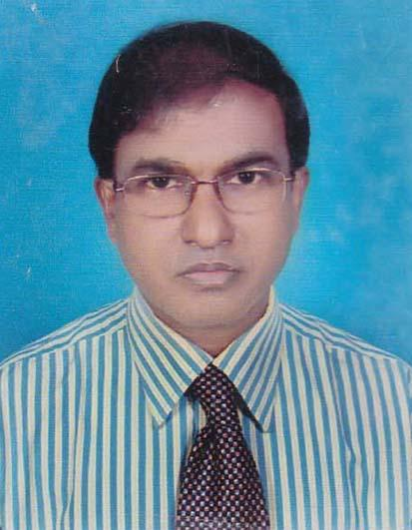 | DR. MD. NURUN NABI  F/Name: Late. Abu Sayed  M/Name: Nurjahan Begum  BM & DC Reg. No: 14667  NID: 6125207156470  Cell: 01716411312  Address: Doctors Quarter, District Hospital, Sherpur, P.O- Sherpur, Upazilla- Sherpur, Dist- Sherpur  Blood Group: B+
33 | Voter No  LM-6100033  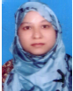 | DR. SHARMIN JAHAN SHAMIMA  F/Name: Dr. Sha Jamal Miah  M/Name: Mst. Morium Begum  BM & DC Reg. No: 48529  NID: 3692848059317  Cell: 01727501311  Address: BASA NO-113, ROAD NO- 2/1 GNIDDANANAYANPUR SHERPUR.  Blood Group: B+
34 | Voter No  LM-6100034 | DR. MD. ANISUR RAHMAN  F/Name: Late. Shamsul Haque  M/Name: Mst. Aklima Khatun  BM & DC Reg. No: 47327  NID: 8928804214314  Cell: 01736440124  Address: Chulk, Putuok, Sherpur Town, Sherpur-2100  Blood Group: O+
35 | Voter No  LM-6100035 | DR. MAYA HORE  F/Name: Nitai Hore  M/Name: Depali Hore  BM & DC Reg. No: 36453  NID: 8928802108358  Cell: 01717274164  Address: SHERPURE DISTRICT HOSPITAL, SHERPUR TOWN, SHERPUR  Blood Group: B-
36 | Voter No  LM-6100036  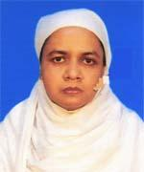 | DR. AMINA RAHMAN  F/Name: Late Momtazur Rahman  M/Name: Jahanara Begum  BM & DC Reg. No: 30970  NID: 3313643249292  Cell: 01714774956  Address: District Hospital Quarter, Shapla-1 Sherpur.  Blood Group: A+
37 | Voter No  LM-6100037  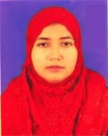 | DR. NURJAHAN BEGUM  F/Name: Md. Abdul Latif  M/Name: Ambia Khatun  BM & DC Reg. No: 46925  NID: 8524904188716  Cell: 01719529131  Address: Sherpur Sadar, Sherpur  Blood Group: B+
38 | Voter No  LM-6100038 | DR. ABDUL KARIM  F/Name: Moqshed Ali  M/Name: Rahima Khatun  BM & DC Reg. No: 34774  NID: 8913725858251  Cell: 01712279303  Address: Medical Officer, District Sadar Hospital, Sherpur.  Blood Group: B+
39 | Voter No  LM-6100039 | DR. MD. NADIM HASAN  F/Name: Md. Amzad Ali  M/Name: Nurunnahar  BM & DC Reg. No: 39183  NID: 8918867395437  Cell: 01719008225  Address: Razinigandha-2, Hospital Quarter District Hspital, Sherpur  Blood Group: O+
40 | Voter No  LM-6100040 | DR. MD. ASADUZZAMAN  F/Name: Md. Belayet Hossain  M/Name: Aklima Khatun  BM & DC Reg. No: 44692  NID: 891886739548  Cell: 01712819049  Address: Vill: Audharia Sutirpar, P.O: Kanpur Bazar Upzilla: Sherpur Sadar, Dist: Sherpur  Blood Group: B+
41 | Voter No  LM-6100041  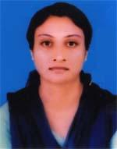 | DR. DEBASRI PAUL  F/Name: Sudhir Paul  M/Name: Sharashawti Paul  BM & DC Reg. No: 53057  NID: 5917440053019  Cell: 01743072419  Address: Bottala : kalir Bazar, Sherpur Town, Sherpur  Blood Group: A+
42 | Voter No  LM-6100042  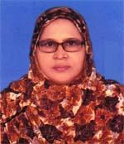 | DR. KAMRUN NAHER  F/Name: Md. Shamsul Haque  M/Name: Zahera Khatun  BM & DC Reg. No: 23295  NID: 2611038776526  Cell: 01959260400  Address: Sherpur, Sadar, Sherpur  Blood Group: AB+

